**Dino_Run - CAPSTONE PROJECT 2**

Georgios Lazari: G21065613

Notes: The coin and the flame on the dino were taken as screenshots from the following images online and modified on Krita app. Also, sometimes the random position that the coin appears happens to be on the cacti.

Flame: <https://www.freepik.com/premium-vector/fire-flame-pixel-art-animation-sprite-frames-bit_20821166.htm#query=burning%20flame%20pixel&position=35&from_view=search&track=ais>

Coin: <https://www.freepik.com/free-vector/dollar_2900482.htm#query=coin&position=0&from_view=search&track=sph>

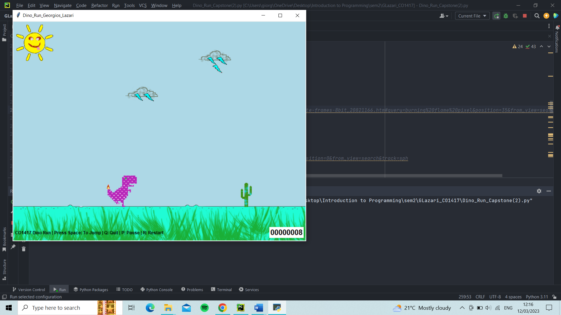**How the game starts**:

**Pressing space to jump over cactuses:**

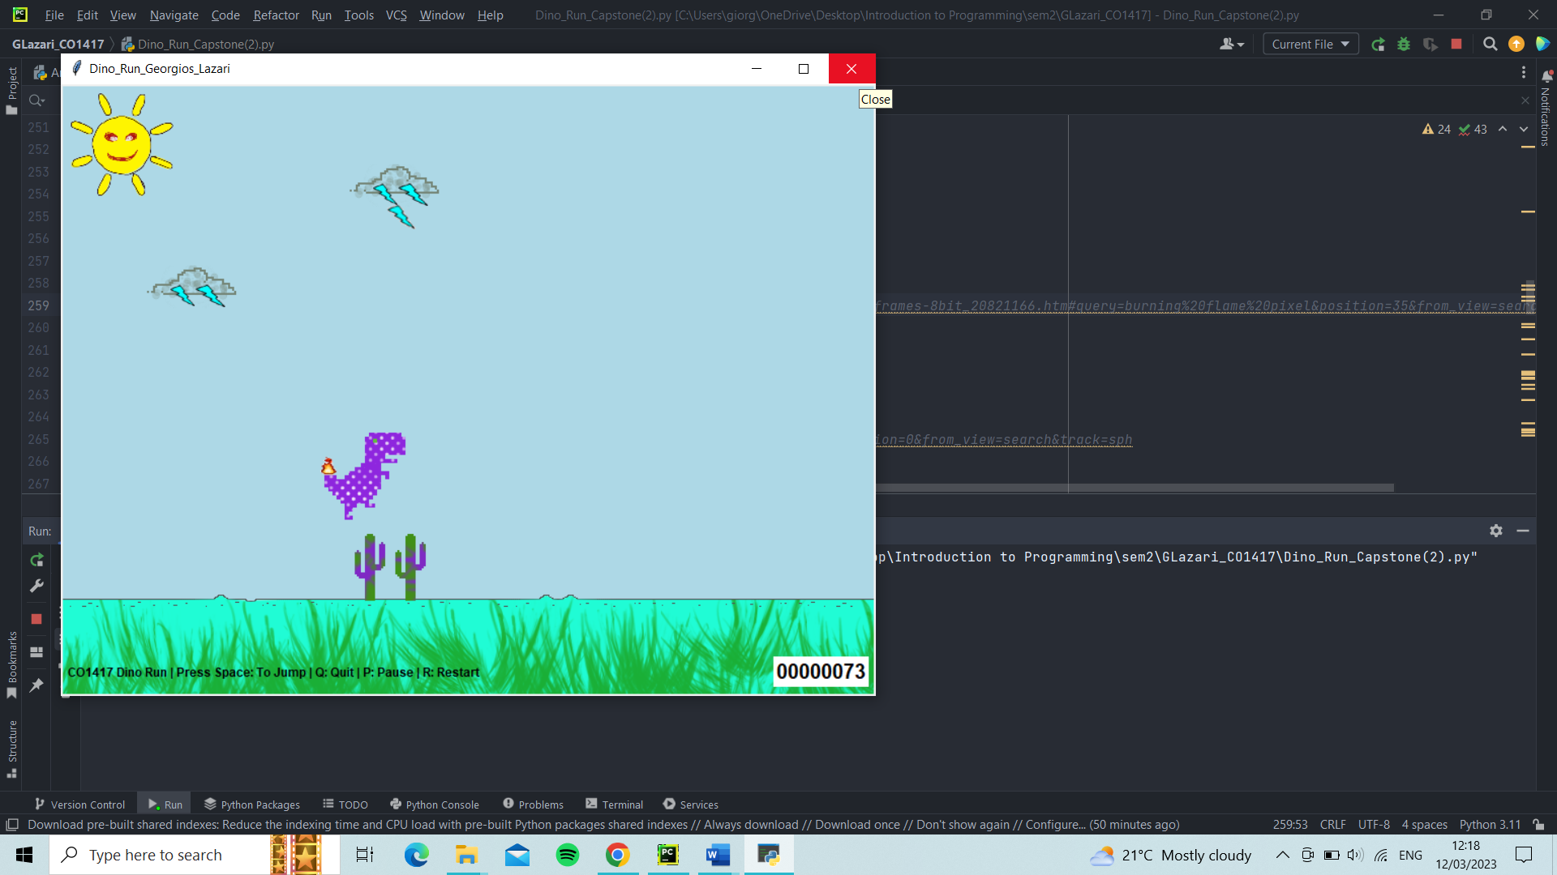

**Press P or p to pause and unpause the game:**

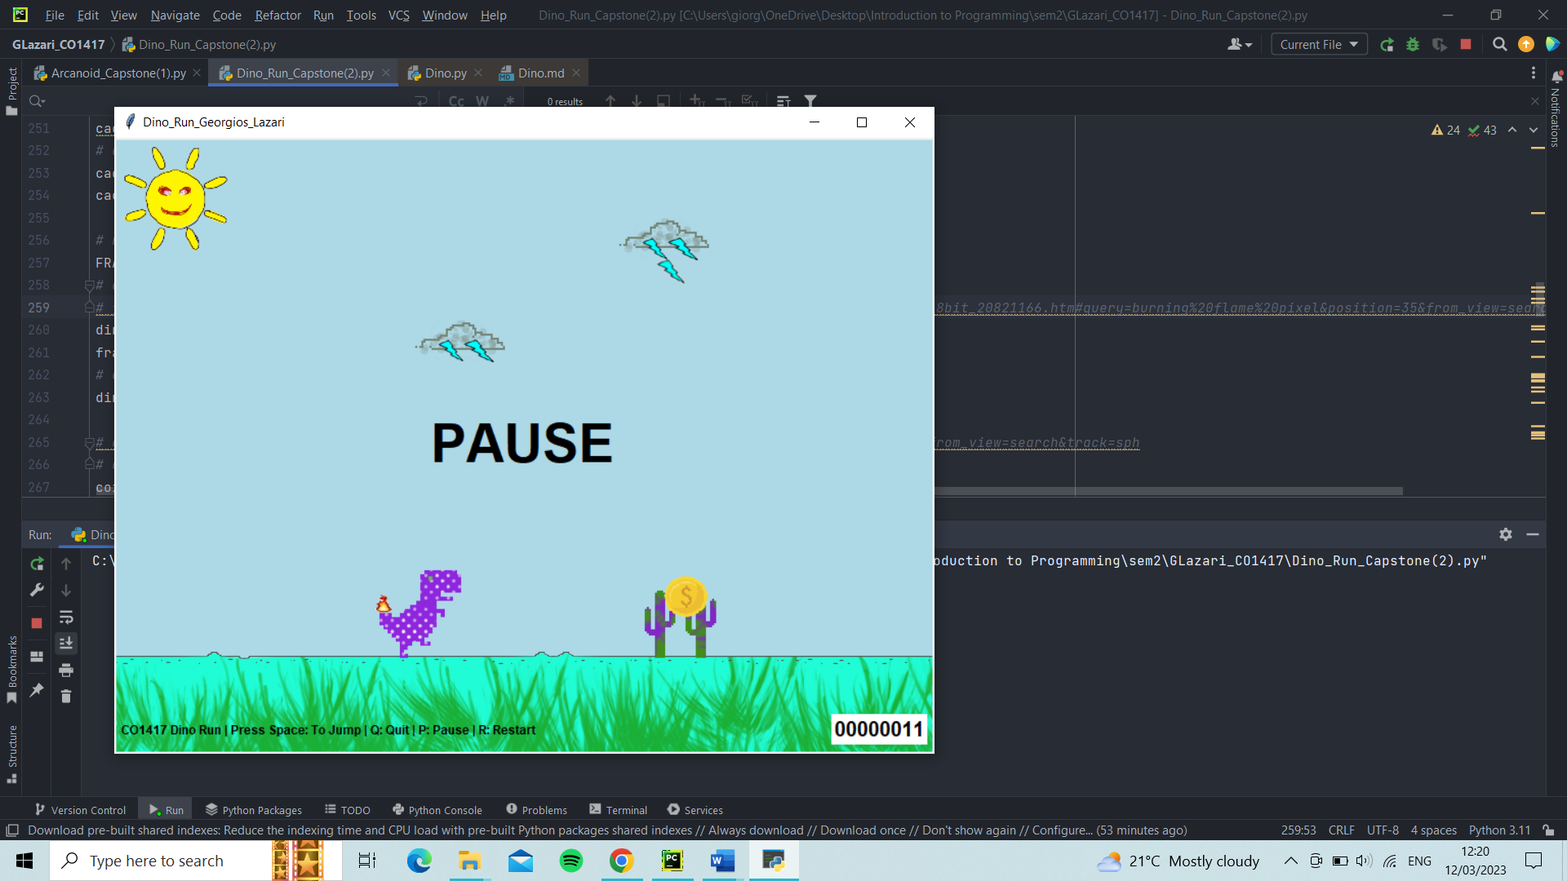

**Press R or r to restart: Score resets to zero, everything goes to their starting position, it’s morning time again.**

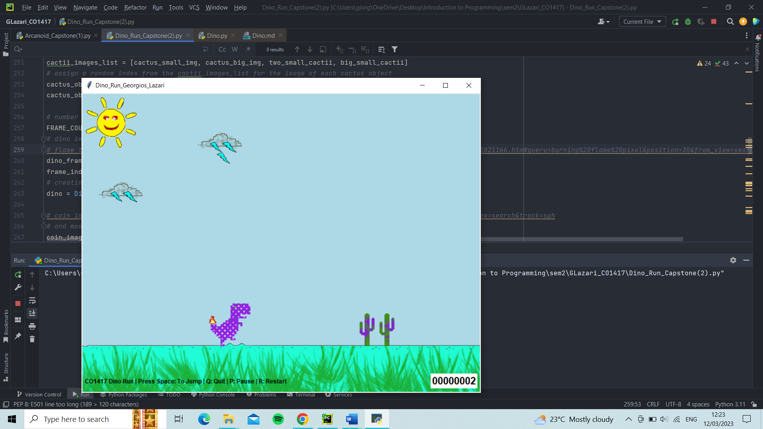

**When the dino collides with a cactus then the game ends:**

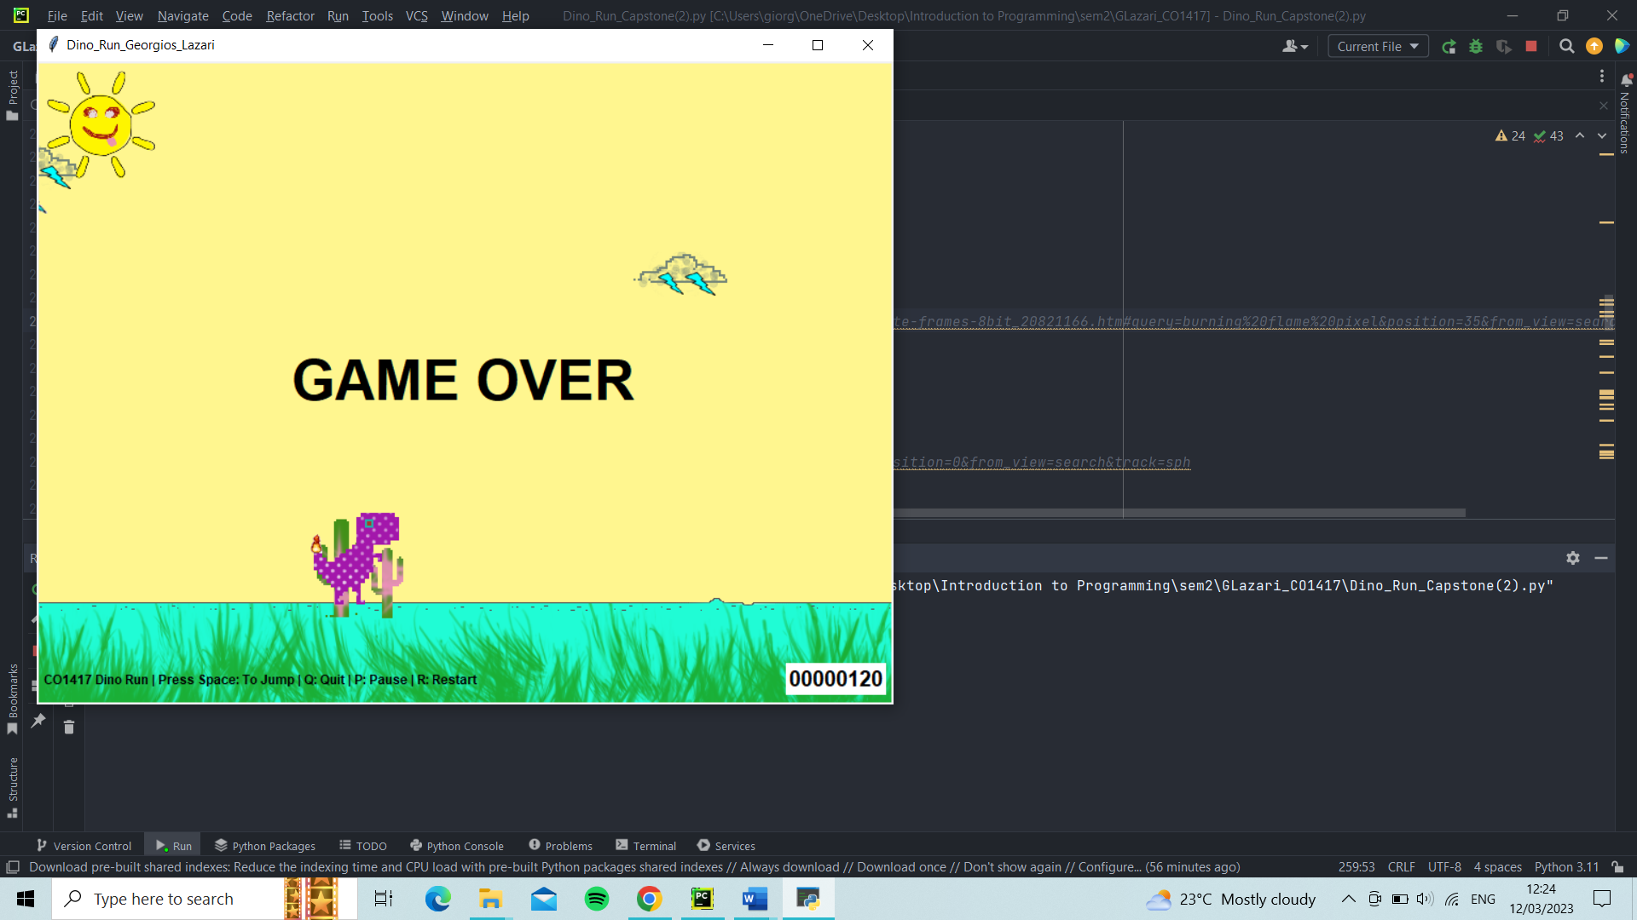

**At 400 points a thunder starts coming down from the cloud making it harder for the Dino to survive. If the dino collides with the thunder then the game ends:**

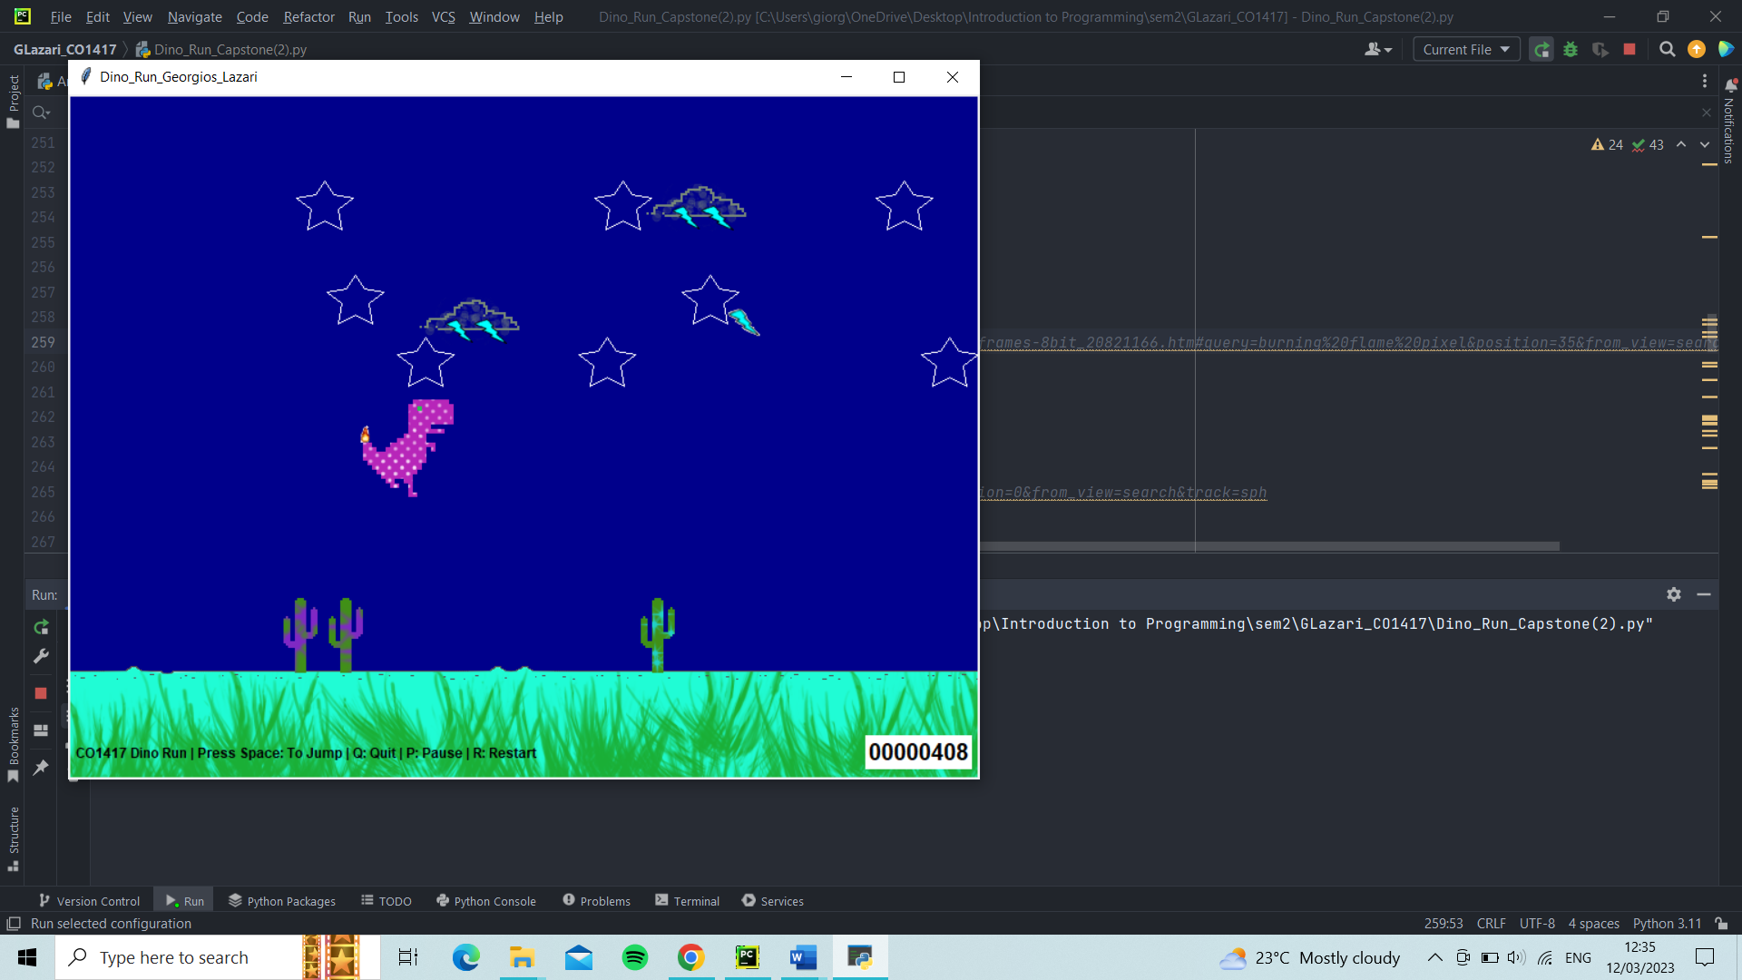

**Every time the Dino collects a coin the score increases by 20 points:**

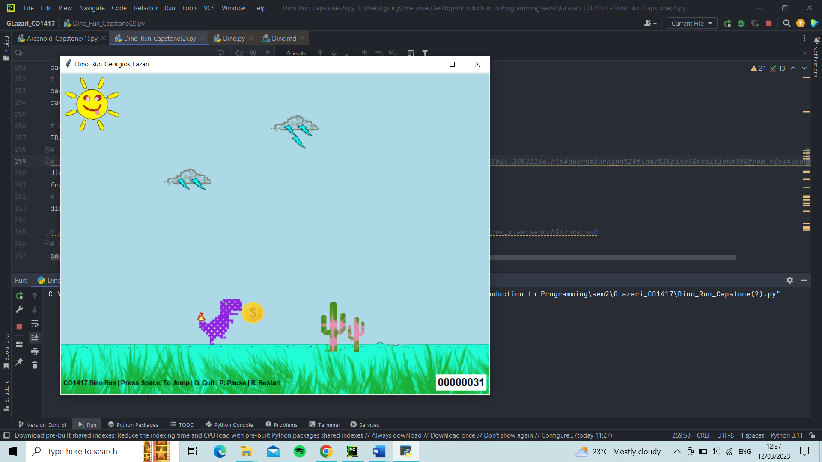

**Every 100 points the time of the day changes from morning to noon, afternoon, sunset and night:**

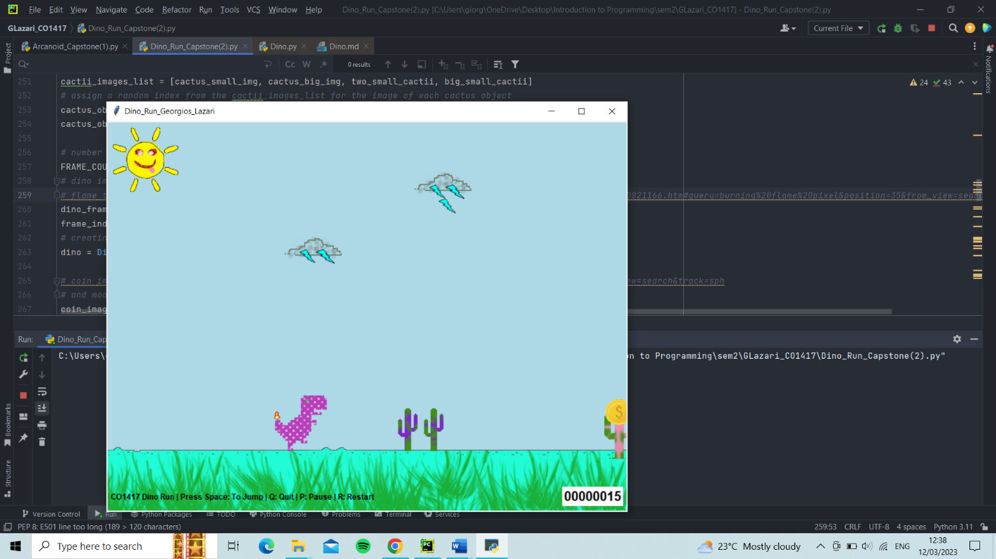

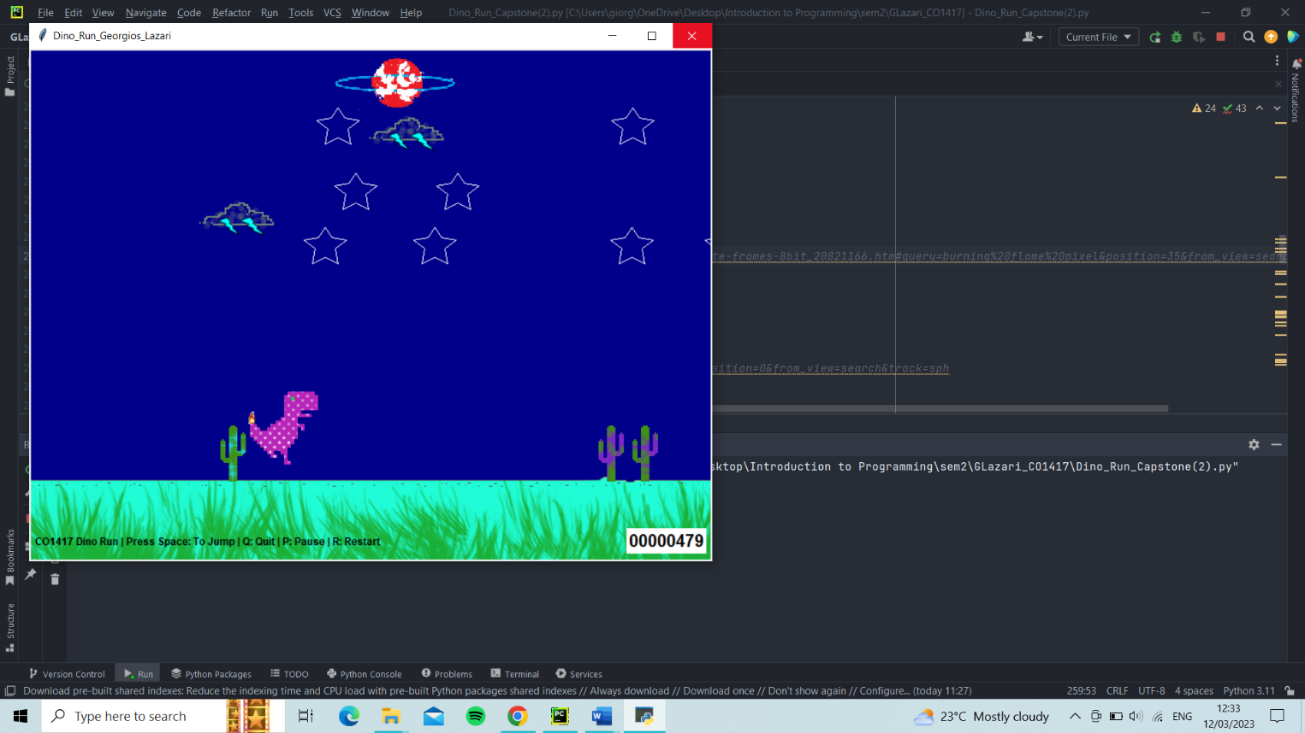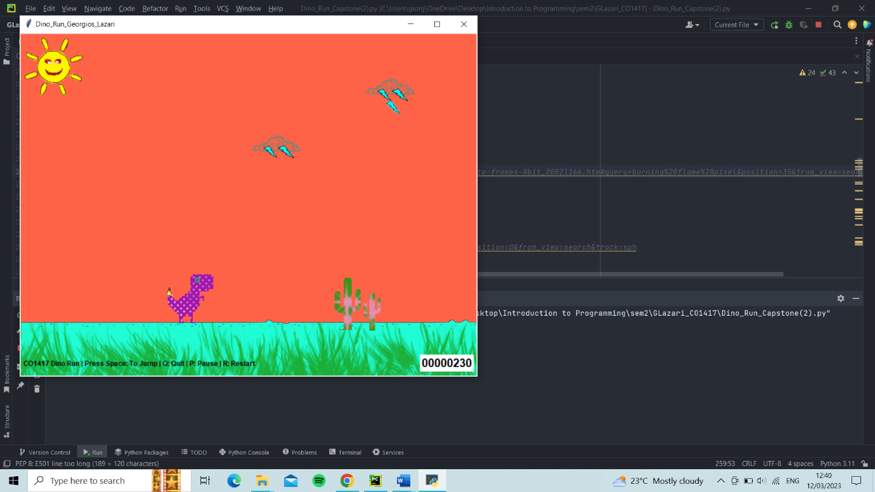**At ni**

**At night the sun disappears, stars appear in the sky and a planet moves across:**